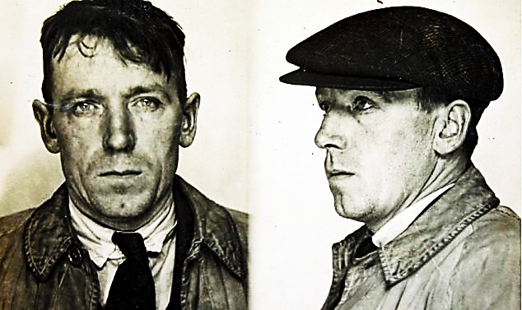

Name: Dodgson John

Age: 45 years

Hair: Black

Height: 5’9”

Marks: Extensively tattooed forearms and Hands.

A general thief and bad character.

Reward: $3,000.00

Wanted