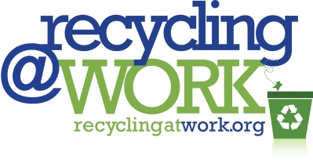
Sample Memo

MEMORANDUM
TO: All Employees
FROM: CEO/President/Business Owner
SUBJECT: New Recycling at Work Initiative
DATE: Month Day, Year
I am pleased to announce [insert company/organization’s name] is a new Pledge Partner of Recycling at Work, a national voluntary initiative by Keep America Beautiful (KAB) to increase recycling in the workplace.
As a Pledge Partner we are committed to:
- Increasing our employees’ awareness of the availability of recyclable services and benefits of recycling in our workplace;
- Enhancing our infrastructure and communications to enable greater recycling in our workplace;
- Identifying cost-effective opportunities to incorporate consideration of end-of-life recyclability and increased recycled content into the products purchased;
- Tracking our progress and recycling achievements; and
- Encouraging other organizations to take the Recycle at Work pledge
Over the coming weeks and months, our volunteer Recycling Team will lead us in making some changes to improve and enhance our current recycling program.
[Insert photo and/or list members of the team]
As we go along, we want you to propose improvements and share your ideas and suggestions. Your solutions and actions will drive our success. Working together, the measures we put in place to increase recycling and reduce waste will make a significant environmental impact and potentially result in cost-savings for our company.
Specific details about our recycling program will be forthcoming soon. In the meantime, you can learn more about this exciting nationwide program at www.recyclingatwork.org
Thank you in advance for your ideas, cooperation and support.

